|  |  |  |  |  |  |  |
| --- | --- | --- | --- | --- | --- | --- |
|  | cg01240931 | cg15020645 | cg16970232 | cg20311501 | cg21634602 | cg24332422 |
| cg01240931 | 1 | 0.548622 | 0.445678 | 0.428298 | 0.426755 | 0.540222 |
| cg15020645 | 0.548622 | 1 | 0.959488 | 0.948973 | 0.945859 | 0.980216 |
| cg16970232 | 0.445678 | 0.959488 | 1 | 0.981687 | 0.975672 | 0.957369 |
| cg20311501 | 0.428298 | 0.948973 | 0.981687 | 1 | 0.984681 | 0.952425 |
| cg21634602 | 0.426755 | 0.945859 | 0.975672 | 0.984681 | 1 | 0.945019 |
| cg24332422 | 0.540222 | 0.980216 | 0.957369 | 0.952425 | 0.945019 | 1 |

Table 1, Methylation status correlation among CpG sites in LUAD

Table 2, Methylation status correlation among CpG sites in LUSC

|  |  |  |  |  |  |  |
| --- | --- | --- | --- | --- | --- | --- |
|  | cg01240931 | cg15020645 | cg16970232 | cg20311501 | cg21634602 | cg24332422 |
| cg01240931 | 1 | 0.67569 | 0.590448 | 0.557767 | 0.551136 | 0.67065 |
| cg15020645 | 0.67569 | 1 | 0.96741 | 0.948966 | 0.954032 | 0.984472 |
| cg16970232 | 0.590448 | 0.96741 | 1 | 0.976671 | 0.961535 | 0.963529 |
| cg20311501 | 0.557767 | 0.948966 | 0.976671 | 1 | 0.980521 | 0.94499 |
| cg21634602 | 0.551136 | 0.954032 | 0.961535 | 0.980521 | 1 | 0.930262 |
| cg24332422 | 0.67065 | 0.984472 | 0.963529 | 0.94499 | 0.930262 | 1 |

Figure 1 , Methylation status correlation among CpG sites in LUAD and LUSC with figure

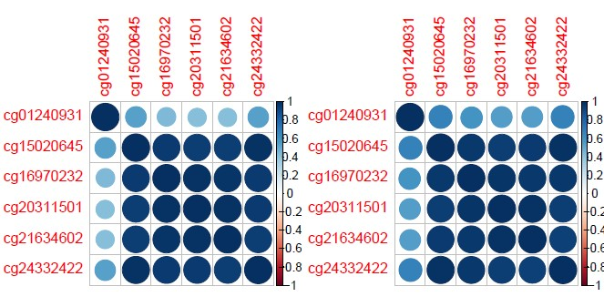

Conclusion,

The correlation between cg012409331, which has been removed in our aticle for its reverse methylation prevalence in NSCLC and normal, and other sites was very low (about 0.5) while the pairwised correlation among other 5 cpg sites were very high(>0.9)